Static Assets Resource

📝Definition
# Source: AI Source: Provided by: [Data Path: Persons Table -> ID Column: 1, Name_En Column: Motasem Essam] -> From: [ChatGPT] on [1/23/2026]
A Static Assets Resource is any non-dynamic file or asset that your application uses for presentation or functionality. These resources are typically served as-is to the client and don’t change unless updated by developers.
Think of static assets as the visual and functional building blocks of your UI — like images, CSS, JS, or fonts.

🔑 Key Points
# Source: AI Source: Provided by: [Data Path: Persons Table -> ID Column: 1, Name_En Column: Motasem Essam] -> From: [ChatGPT] on [1/23/2026]
- Includes images, stylesheets, scripts, fonts, icons
- Usually stored in a public folder for direct access
- Improves performance when cached by browsers
- Keeps UI consistent and maintainable

🧱 Examples

1️⃣ Web Application Example
# Source: AI Source: Provided by: [Data Path: Persons Table -> ID Column: 1, Name_En Column: Motasem Essam] -> From: [ChatGPT] on [1/23/2026]
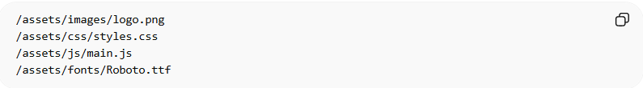
/assets/images/logo.png
/assets/css/styles.css
/assets/js/main.js
/assets/fonts/Roboto.ttf
- Each file is a static asset resource
- Can be reused across multiple pages or components

2️⃣ Laravel Example
# Source: AI Source: Provided by: [Data Path: Persons Table -> ID Column: 1, Name_En Column: Motasem Essam] -> From: [ChatGPT] on [1/23/2026]

public/images/logo.png
public/css/app.css
public/js/app.js
- Laravel serves these assets directly from the public folder
- Can use mix() or asset() helpers to manage paths
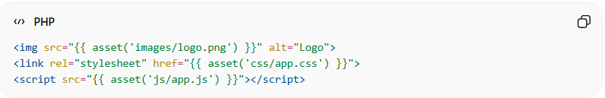
<img src="{{ asset('images/logo.png') }}" alt="Logo">
<link rel="stylesheet" href="{{ asset('css/app.css') }}">
<script src="{{ asset('js/app.js') }}"></script>

❌ Bad Example
# Source: AI Source: Provided by: [Data Path: Persons Table -> ID Column: 1, Name_En Column: Motasem Essam] -> From: [ChatGPT] on [1/23/2026]
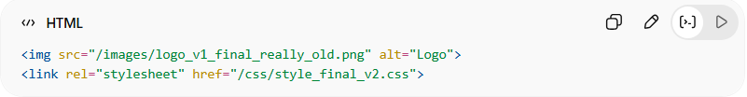
<img src="/images/logo_v1_final_really_old.png" alt="Logo">
<link rel="stylesheet" href="/css/style_final_v2.css">
Problems:
- Hardcoded file versions → difficult to maintain
- No central organization
- Can cause broken links or inconsistencies

✅ Good Example
# Source: AI Source: Provided by: [Data Path: Persons Table -> ID Column: 1, Name_En Column: Motasem Essam] -> From: [ChatGPT] on [1/23/2026]
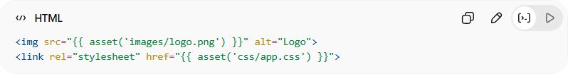
<img src="{{ asset('images/logo.png') }}" alt="Logo">
<link rel="stylesheet" href="{{ asset('css/app.css') }}">
- Centralized path management
- Easier to update files without touching code
- Promotes consistency and maintainability

💡 Summary:
# Source: AI Source: Provided by: [Data Path: Persons Table -> ID Column: 1, Name_En Column: Motasem Essam] -> From: [ChatGPT] on [1/23/2026]
Static Assets are presentation and UI files served as-is to the client, forming the visual and interactive components of your application, and should be centralized and organized.

